**unit2_lecture1_introduction to embedded system**

**differences between the roles of a Communication Engineer, Telecommunications Engineer, Analog Engineer, Digital Designer, Network Engineer, and Embedded Systems Engineer:**

**Communication Engineer:**

**Focus:** General focus on designing and maintaining communication systems.

**Responsibilities:** Involves working on various types of communication systems, including wireless, satellite, radio, and fiber-optic communications. They may work on both hardware and software aspects of these systems.

**Skills Required:** Knowledge of signal processing, modulation, coding, and networking.

**Telecommunications Engineer:**

**Focus:** Specializes in telecommunications networks and systems.

**Responsibilities:** Designing, implementing, and managing telecommunications systems like telephone networks, internet services, and cable TV. They often work with hardware such as routers, switches, and transmission lines.

**Skills Required:** Understanding of network protocols, telecommunication standards, and network infrastructure.

**Analog Engineer:**

**Focus:** Works with analog electronics and systems.

**Responsibilities:** Designing and testing analog circuits, such as amplifiers, oscillators, and filters. They focus on continuous signal processing.

**Skills Required:** Proficiency in circuit design, signal integrity, and use of tools like oscilloscopes and spectrum analyzers.

**Digital Designer:**

**Focus:** Specializes in digital circuit design and systems.

**Responsibilities:** Designing digital circuits such as microprocessors, FPGAs, and digital signal processors (DSPs). They work on binary logic and digital signal processing.

**Skills Required:** Knowledge of digital logic design, VHDL/Verilog programming, and simulation tools like ModelSim or Quartus.

**Network Engineer:**

**Focus:** Focuses on computer networks.

**Responsibilities:** Designing, implementing, and managing computer networks, including local area networks (LANs), wide area networks (WANs), and intranets. They ensure network security and performance.

**Skills Required:** Understanding of network protocols (TCP/IP, DNS, DHCP), network hardware (routers, switches), and cybersecurity practices.

**Embedded Systems Engineer:**

**Focus:** Works with embedded systems, which are specialized computing systems within larger systems.

**Responsibilities:** Designing and developing embedded systems, such as microcontrollers and real-time operating systems (RTOS). They often work on firmware and software that directly interacts with hardware.

**Skills Required:** Proficiency in embedded programming (C/C++), understanding of microcontrollers/microprocessors, and knowledge of hardware-software integration.

Each of these roles has a distinct focus area and requires specialized knowledge and skills, though there may be some overlap in terms of fundamental engineering principles.

**the differences between VLSI, ASIC, PLD, FPGA, and SoC:**

1. **VLSI (Very-Large-Scale Integration):**
   * **Definition:** VLSI refers to the process of creating integrated circuits by combining thousands to millions of transistors on a single chip.
   * **Scope:** It encompasses the design and manufacture of ICs with high transistor counts.
   * **Applications:** Used in the design of microprocessors, memory chips, and custom ICs.
   * 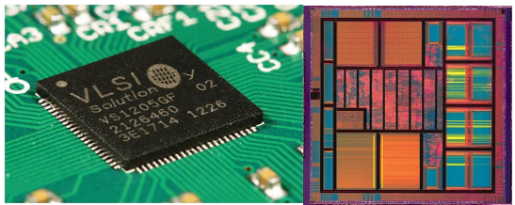**Characteristics:** VLSI design includes various subfields like digital, analog, mixed-signal, and RF IC design.
2. **ASIC (Application-Specific Integrated Circuit):**
   * **Definition:** ASICs are custom-designed chips created for a specific application or purpose.
   * **Scope:** Once designed and fabricated, ASICs cannot be reprogrammed.
   * **Applications:** Used in high-volume applications where performance and efficiency are critical, such as in smartphones, automotive electronics, and networking equipment.
   * 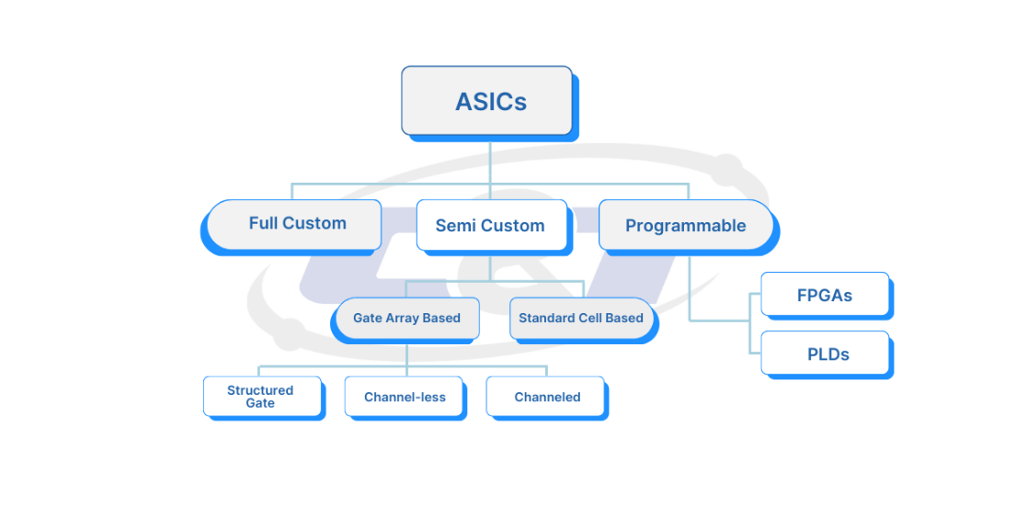**Characteristics:** Offers high performance and low power consumption for the specific task it is designed for, but has high initial design and manufacturing costs.
3. **PLD (Programmable Logic Device):**
   * **Definition:** PLDs are semiconductor devices that can be programmed to perform specific logic functions after manufacturing.
   * **Scope:** Includes a range of programmable devices like SPLDs (Simple PLDs), CPLDs (Complex PLDs), and FPGAs.
   * **Applications:** Used in applications requiring flexibility and rapid prototyping.
   * 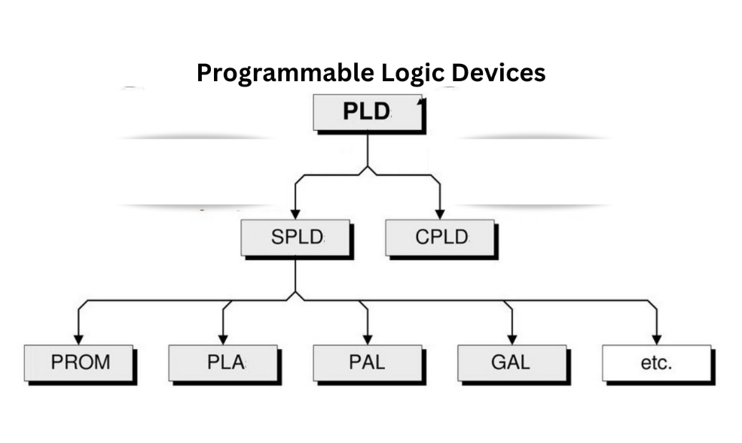**Characteristics:** Can be reprogrammed multiple times, making them versatile for various applications.
4. **FPGA (Field-Programmable Gate Array):**
   * **Definition:** FPGAs are a type of PLD that can be programmed and reprogrammed in the field to perform complex logic functions.
   * **Scope:** Consists of an array of programmable logic blocks and interconnects.
   * **Applications:** Used in prototyping, telecommunications, signal processing, and custom computing tasks.
   * 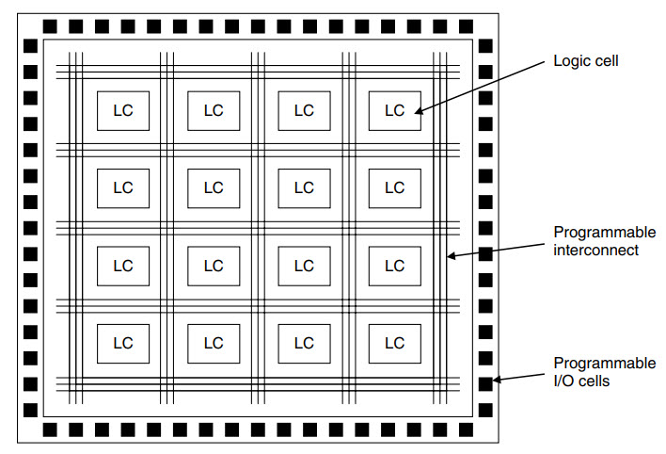**Characteristics:** Offers high flexibility, reconfigurability, and parallel processing capabilities, but generally consumes more power and may be slower compared to ASICs.
5. **SoC (System on Chip):**
   * **Definition:** SoCs integrate all components of a computer or other electronic systems into a single chip, including the CPU, memory, peripherals, and I/O interfaces.
   * **Scope:** Combines both digital and analog components on a single chip.
   * **Applications:** Used in mobile devices, embedded systems, IoT devices, and other applications requiring compact and efficient designs.
   * 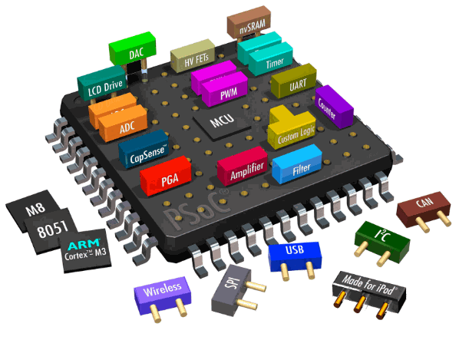**Characteristics:** Provides high integration, reduces the overall size and power consumption, and can be customized for specific applications. SoCs often include both general-purpose and application-specific components.

**Summary**

* **VLSI**: Broad field encompassing IC design with high transistor counts.
* **ASIC**: Custom-designed, high-performance ICs for specific applications.
* **PLD**: Programmable devices for flexible logic functions.
* **FPGA**: Reprogrammable PLDs for complex and parallel processing tasks.
* **SoC**: Highly integrated chips combining various system components into one.

**the differences between Verilog and VHDL:**

**Verilog**

* **Origin:** Developed in the mid-1980s by Gateway Design Automation.
* **Usage:** Widely used in the United States and commercial semiconductor industry.
* **Syntax:** C-like, concise, and easier for those with a software background.
* **Language Features:** Handles concurrency naturally, supports powerful simulation and hierarchical design.
* **Standardization:** IEEE 1364.
* 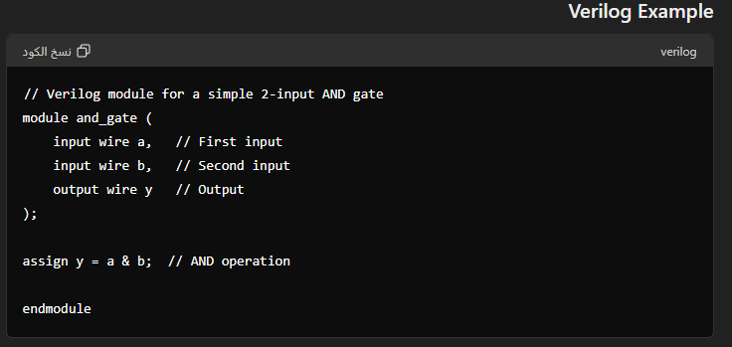**Applications:** Commonly used for FPGA and ASIC design and verification.

**VHDL**

* **Origin:** Developed in the early 1980s as part of the U.S. Department of Defense's VHSIC program.
* **Usage:** Popular in Europe, academia, defense, and aerospace industries.
* **Syntax:** Ada-like, verbose, and strongly typed, leading to more precise and error-resistant designs.
* **Language Features:** Excellent concurrency handling, extensive support for simulation and hierarchical design.
* **Standardization:** IEEE 1076.
* 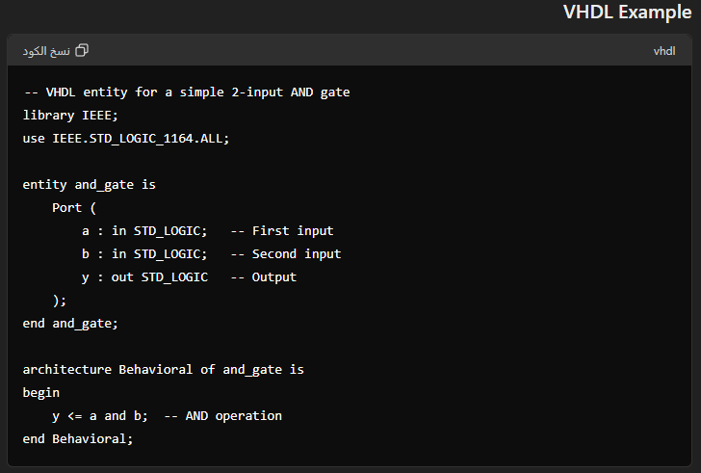**Applications:** Used for FPGA and ASIC design, especially in projects requiring high reliability and rigor.

**Key Differences**

* **Syntax and Learning Curve:** Verilog's C-like syntax is easier for software programmers, while VHDL's verbose and strict syntax provides greater precision.
* **Typing System:** Verilog has weak typing (more flexible but prone to errors), whereas VHDL has strong typing (more robust and less error-prone).
* **Industry Preference:** Verilog is preferred in commercial applications, especially in the U.S., while VHDL is favored in Europe, academia, and high-reliability industries like aerospace and defense.
* **Standard Libraries:** VHDL offers rich predefined libraries, while Verilog relies more on user-defined libraries and custom coding for complex operations.

**Summary**

* **Verilog:** Easier for software programmers, concise, widely used in commercial applications.
* **VHDL:** More precise and robust, favored in academia and high-reliability industries, verbose and strongly typed.

**What is an SoC FPGA?**

**SoC (System on Chip) FPGAs (Field-Programmable Gate Arrays)** combine the flexibility of FPGA technology with the processing power of a hardened processor core on a single chip. This integration allows for more efficient and powerful system designs.

**Overview of SoC FPGAs**

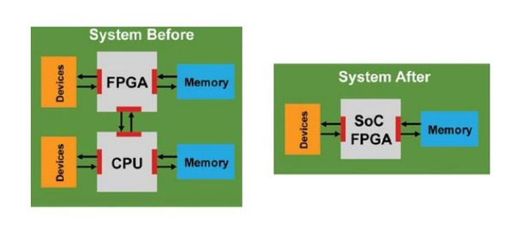**SoC FPGAs** are designed to provide a high level of integration, combining programmable logic with processor cores (such as ARM Cortex-A series) and often additional peripherals and interfaces. This makes them suitable for a wide range of applications, including embedded systems, industrial automation, automotive, and communications.

**Examples of SoC FPGA Families**

1. **Xilinx Zynq-7000 and Zynq UltraScale+ MPSoC:**
   * Combines ARM Cortex-A9 or Cortex-A53 processor cores with FPGA fabric.
   * Provides a rich set of peripherals and high-speed connectivity options.
   * Widely used in applications requiring high processing power and flexibility.
2. **Intel (Altera) Arria and Cyclone V SoC FPGAs:**
   * Features ARM Cortex-A9 processor cores integrated with FPGA fabric.
   * Offers a range of devices with varying levels of logic density and performance.
   * Suitable for industrial, automotive, and communication applications.
3. **Microsemi (Microchip) PolarFire SoC:**
   * Integrates RISC-V processor cores with FPGA fabric.
   * Focuses on low power consumption and security features.
   * Targeted at applications in defense, aerospace, and industrial automation.

**Summary**

SoC FPGAs combine the flexibility of FPGA technology with the processing power of hardened processor cores, providing a highly integrated solution for a wide range of applications. They offer high performance, flexibility, power efficiency, and comprehensive development tools, making them suitable for complex and demanding system designs.

**What's the embedded system?**

* An embedded system is a special-purpose computer system designed to perform one or a few dedicated functions
* often with real-time computing constraints.
* It is usually embedded as part of a complete device including hardware and mechanical parts. In contrast, a general-purpose computer, such as a personal computer, can do many different tasks depending on programming.
* 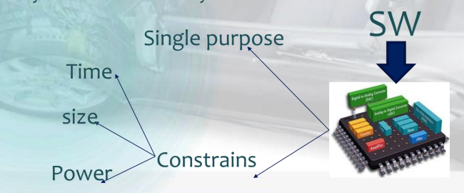Embedded systems control many of the common devices in use today.

**Embedded System Classification**

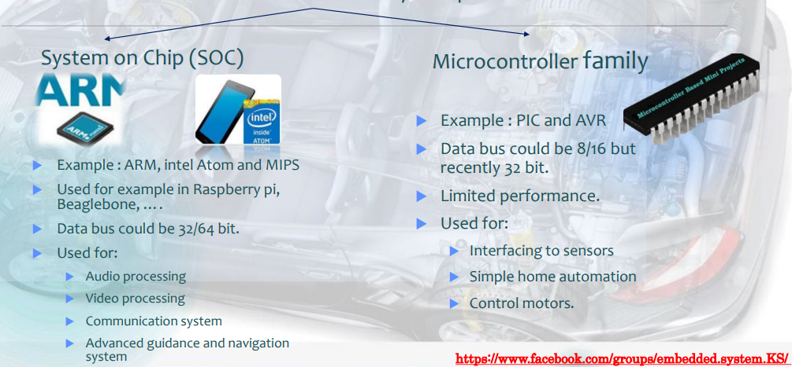There are two main families of embedded system platforms

**differences between OS Application and Bare metal SW**

**Bare metal SW**

“Bare metal" means your application is accessing the silicon chip directly without any intermediary like an OS.

The application is the only software that executes on the microprocessor/microcontroller

So we can considered that the Drivers is a bare metal Code and the bios also.

**OS Application**

Write your application on the top of the Operating System

On desktop computers, the selection of an operating system (OS) is largely a matter of taste - Windows vs Apple vs Linux. There is relatively little choice.

For an embedded system, the matter is much more complex. The large number of options available reflect the wide diversity of embedded applications.

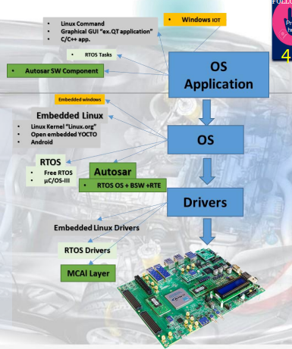

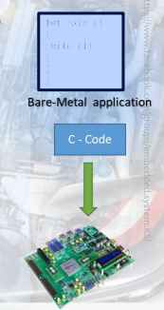

**Hypervisors**

**Virtualization** you can run operating systems called guests, inside a sandbox contained under the control of another piece of software (the hypervisor) that manages all interaction of the guest toward hardware. The hypervisor runs at a more privileged level of hardware access than the operating system (OS) kernel (supervisor) and user privilege of the guest OS

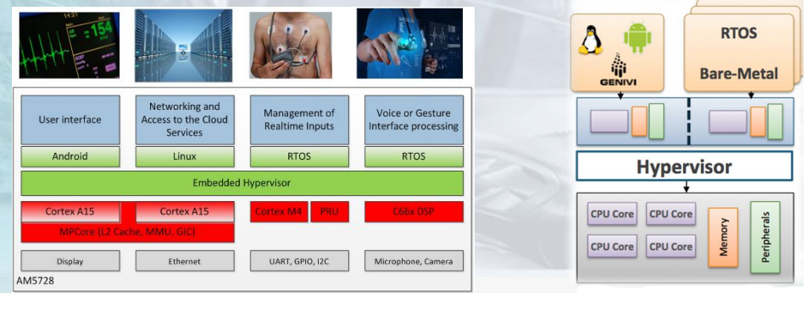

**What is ADAS?**

Advanced Driver Assistance Systems, or ADAS, are systems to help the driver in the driving process. When designed with a safe Human Machine Interface, they should increase car safety and more generally road safety.

**ADAS include a wide range of safety features for vehicles such as**

* + Autonomous emergency braking (AEB)
  + Lane departure warning (LDW)
  + Lane keeps assist υ adaptive lighting and night vision cameras.
  + 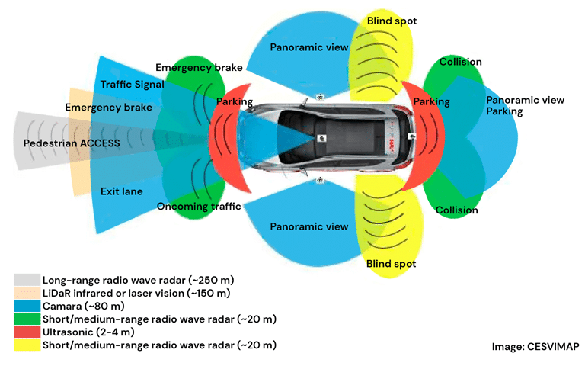It is predicted that over 40% of all vehicles on the road will feature ADAS by 2020.

**The ISO 26262 Standard**

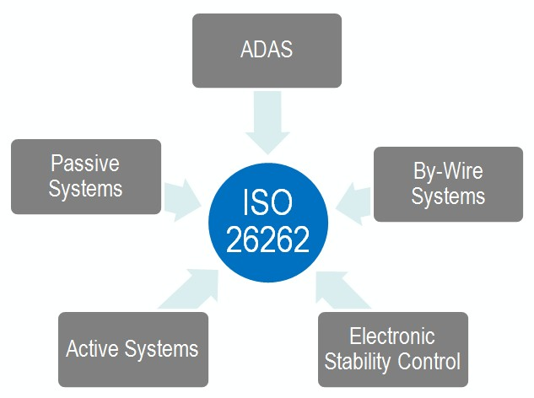**ISO 26262** is an international standard for the functional safety of electrical and electronic systems in production automobiles. It provides a framework for ensuring that automotive systems function correctly and safely, even in the presence of hardware and software faults

**What is Autosar ?**

**AUTOSAR (Automotive Open System Architecture)** is an open and standardized automotive software architecture, jointly developed by automobile manufacturers, suppliers and tool developers. The AUTOSAR-standard enables the use of a component-based software design model for the design of a vehicular system. The design model uses application software components which are linked through an abstract component, named the virtual function bus.

**Autosar Layered Architecture**

